DSA 0601 - Data handling and visualization
Set 1 - Monthly Sales Data

Name : B.Jahnavi
Reg.no:192325043

1.Line graph
Code:
library(ggplot2)

sales <- data.frame(
Month = c("January", "February", "March", "April", "May","June", "July", "August", "September", "October","November", "December"),
Sales = c(15000, 18000, 22000, 20000, 23000, 25000,27000, 26000, 29000, 31000, 33000, 35000))

ggplot(sales, aes(x = Month, y = Sales, group = 1)) +
geom_line() +geom_point() +labs(title = "Monthly Sales", x = "Month", y = "Sales") +
theme_minimal()

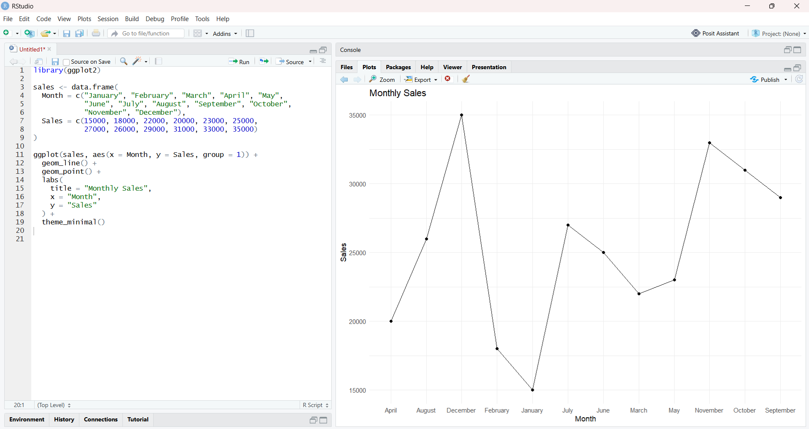

- Bar graph
Code:
products <- data.frame(
Product = c("Product A", "Product B", "Product C","Product D", "Product E"),
Sales = c(95000, 82000, 76000, 68000, 55000)

ggplot(products, aes(x = Product, y = Sales)) +
geom_bar(stat = "identity") +
geom_text(aes(label = Sales), vjust = -0.5) +
labs(
title = "Top-Selling Products",
x = "Product",
y = "Sales ) +theme_minimal()
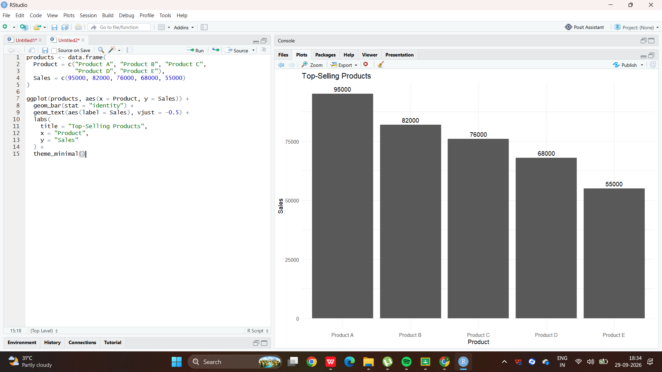

- Scatterplot
Code:
advertising <- data.frame(
Advertising_Budget = c(5000, 6000, 7000, 6500, 8000, 8500,9000, 8800, 9500, 10000, 11000, 12000),
Sales = c(15000, 18000, 22000, 20000, 23000, 25000,27000, 26000, 29000, 31000, 33000, 35000))

ggplot(advertising,aes(x = Advertising_Budget, y = Sales) +
geom_point(size = 3) +
geom_smooth(method = "lm", se = FALSE) +
labs(title = "Advertising Budget vs Monthly Sales",x = "Advertising Budget",y = "Monthly Sales") +theme_minimal()

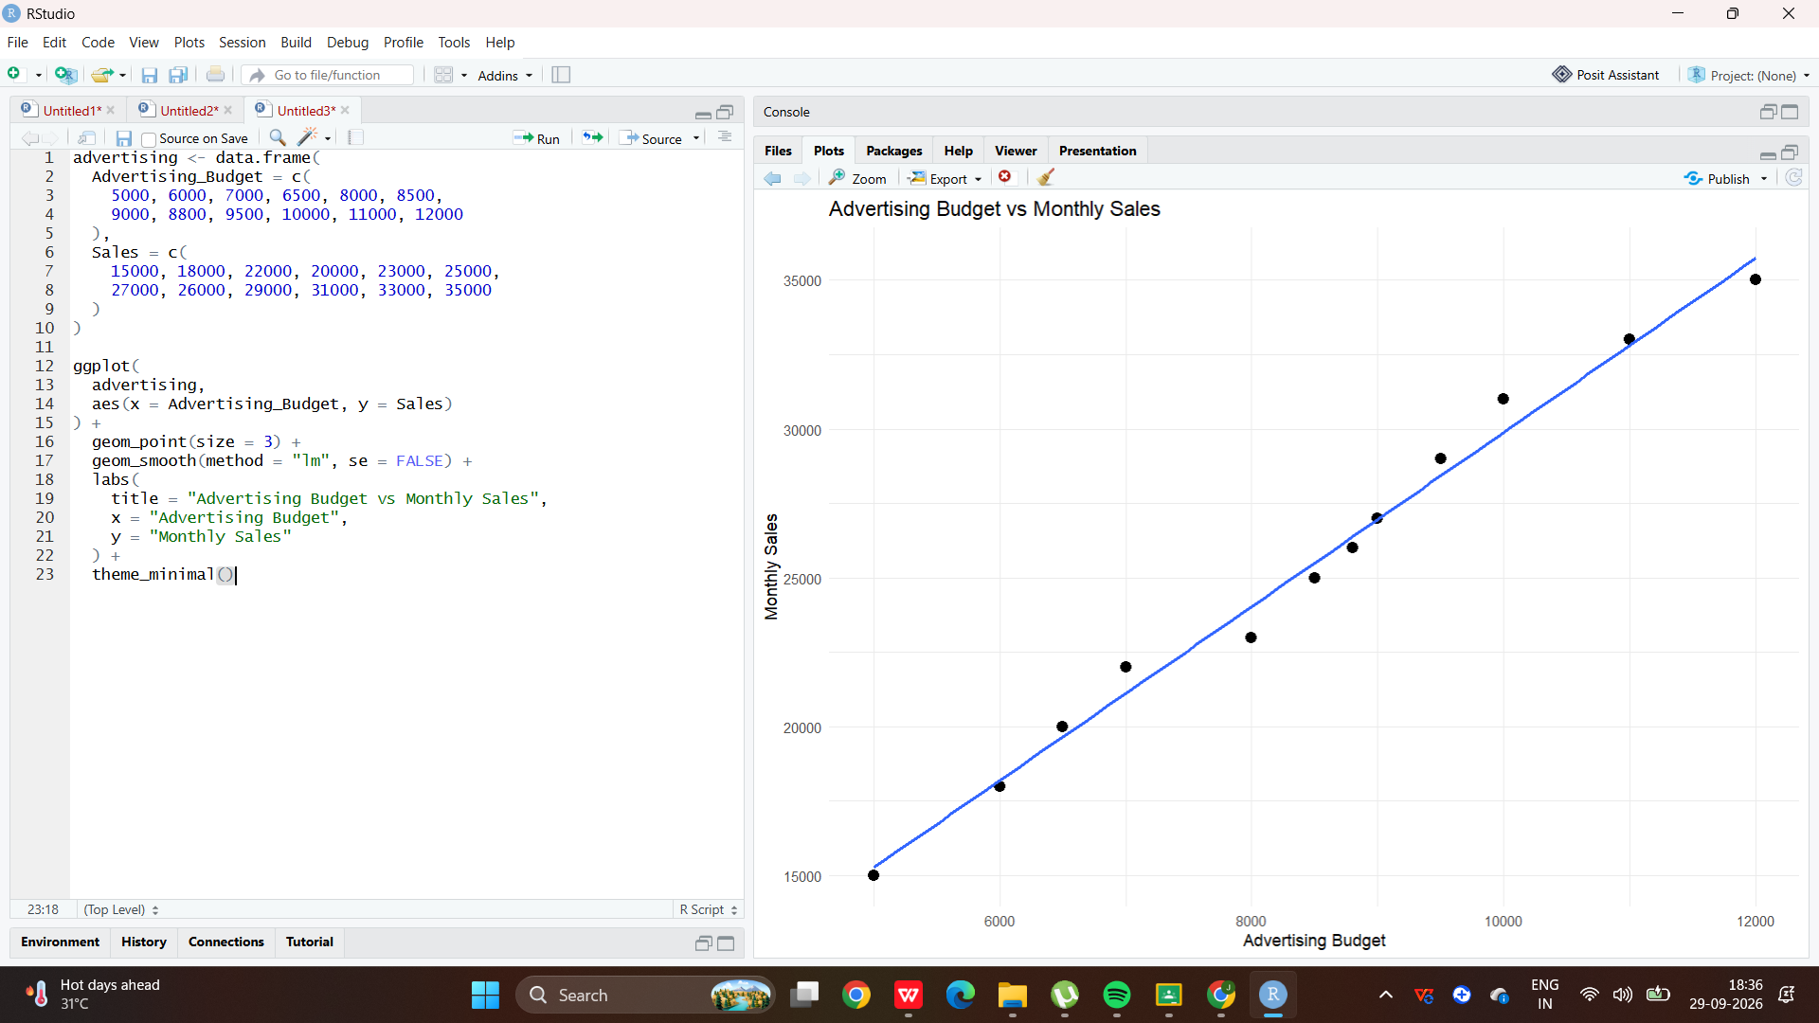
- Correlation
Code:
cor(
advertising$Advertising_Budget,
advertising$Sales
)

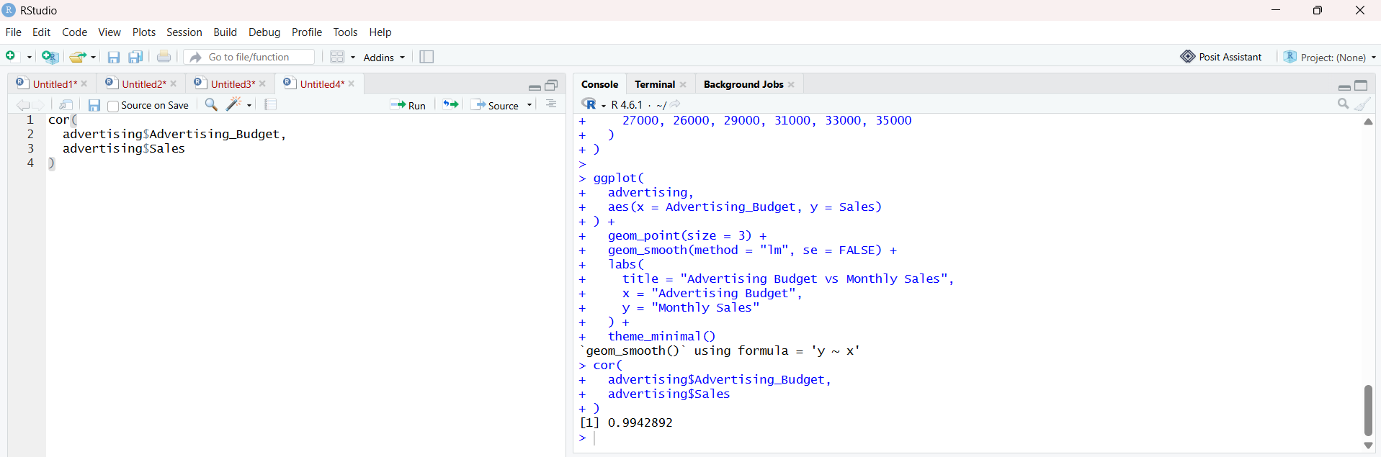

Set 2 - Customer Satisfaction

- Histogram of Customer Ages
Code:
library(ggplot2)

customer_data <- data.frame(
Customer_ID = c(1, 2, 3, 4, 5),
Age = c(25, 30, 35, 28, 40),
Satisfaction_Score = c(4, 5, 3, 4, 5)
)

ggplot(customer_data, aes(x = Age)) +
geom_histogram(binwidth = 5, fill = "skyblue", color = "black") +
labs(
title = "Distribution of Customer Ages",
x = "Age",y = "Number of Customers") +theme_minimal()

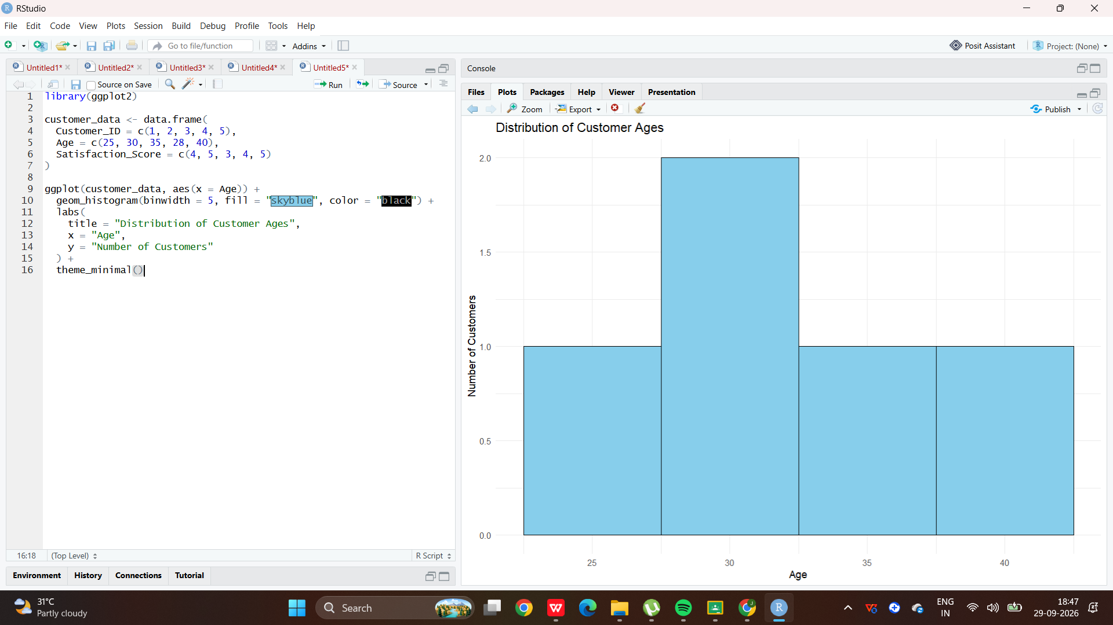

- Pie Chart of Satisfaction Scores
Code:
library(ggplot2)

satisfaction <- as.data.frame(table(customer_data$Satisfaction_Score))
colnames(satisfaction) <- c("Score", "Count")

ggplot(satisfaction, aes(x = "", y = Count, fill = Score)) +
geom_bar(stat = "identity", width = 1) +
coord_polar("y") +
labs(
title = "Customer Satisfaction Score Distribution",
fill = "Satisfaction Score"
) +
theme_void()

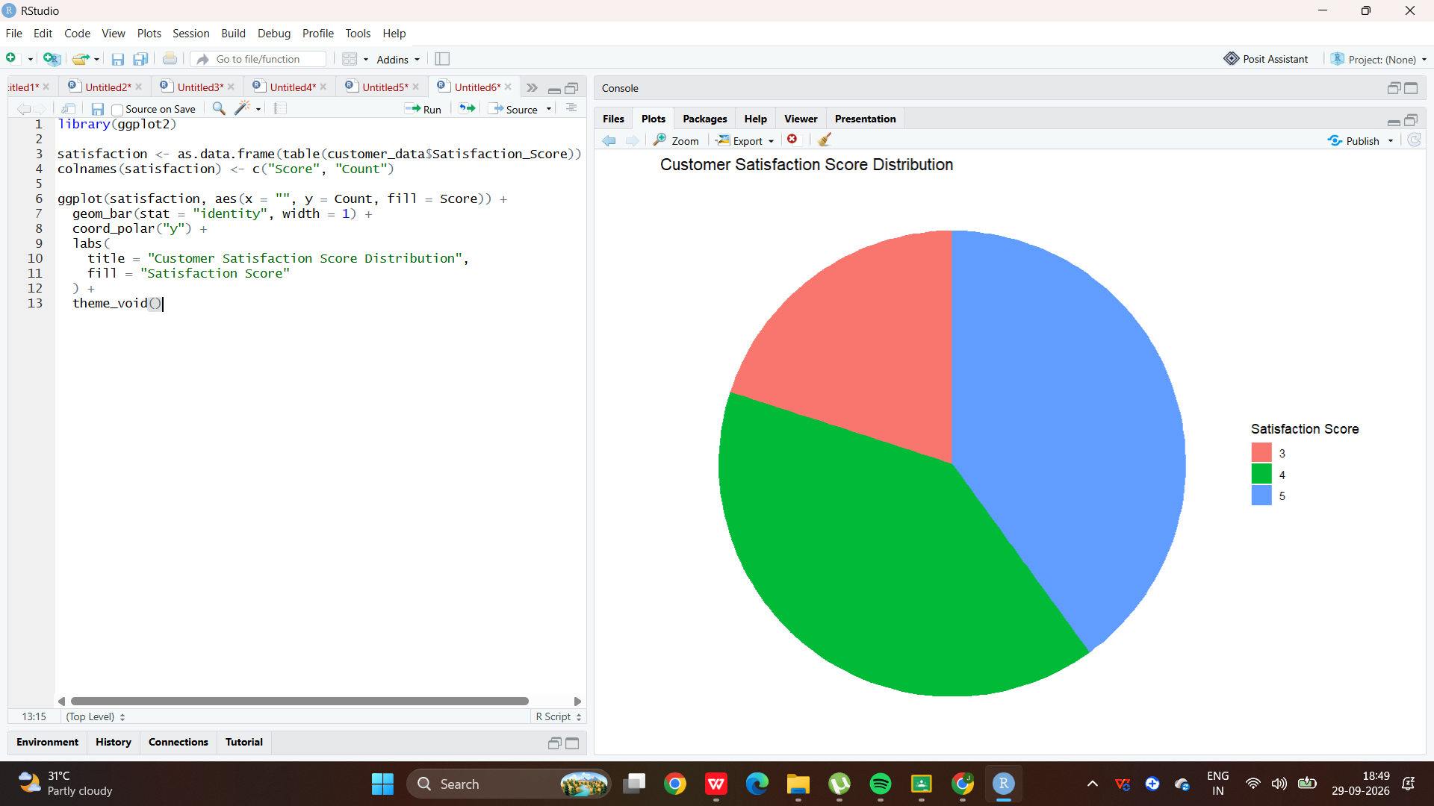

- Stacked Bar Chart of Satisfaction by Age Group
Code:
customer_data$Age_Group <- cut(
customer_data$Age,
breaks = c(20, 29, 39, 49),
labels = c("20-29", "30-39", "40-49")
)
ggplot(customer_data,
aes(x = Age_Group, fill = factor(Satisfaction_Score))) +geom_bar() +
labs(title = "Customer Satisfaction by Age Group", x = "Age Group",y = "Number of Customers",fill = "Satisfaction Score") +theme_minimal()
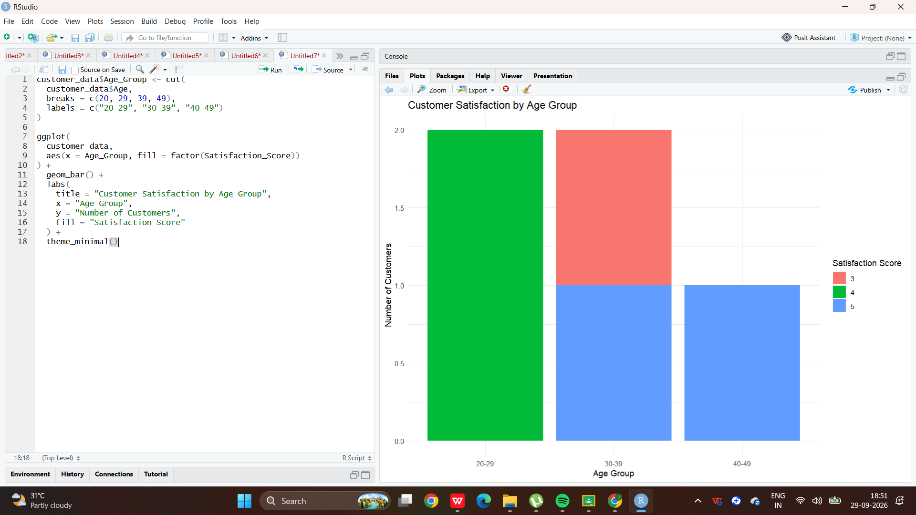
- Word Cloud of Customer Feedback
Code:
library(wordcloud)
library(RColorBrewer)

feedback <- c(
"Excellent service and friendly staff",
"Very satisfied with the product",
"Good quality and fast service",
"Excellent product",
"Friendly customer service",
"Very good experience",
"Satisfied with the quality",
"Fast delivery and excellent service",
"Good product but delivery was slow",
"Very happy with the service"
)

words <- tolower(paste(feedback, collapse = " "))

wordcloud(
words,
min.freq = 1,
max.words = 50,
random.order = FALSE,
colors = brewer.pal(8, "Dark2")
)
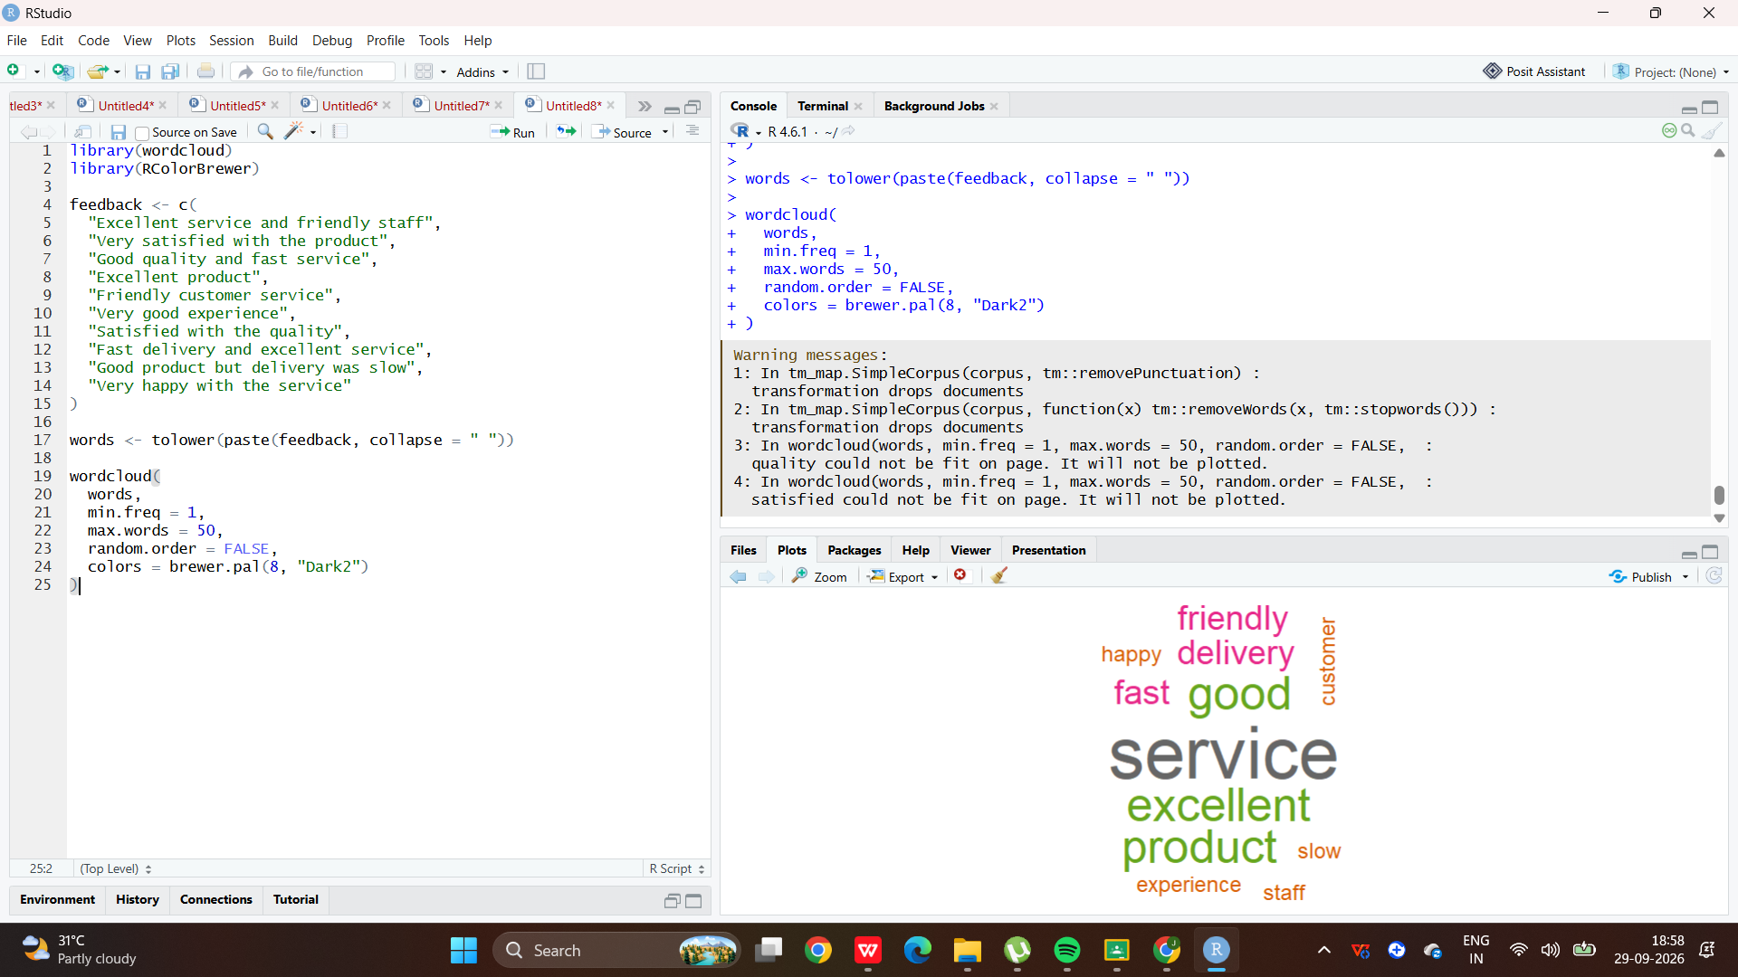

Set 3 – Employee Performance Evaluation

- Line Chart – Monthly Performance/Sales Trend
Code:
library(ggplot2)

monthly_sales <- data.frame(
Month = c(
"January", "February", "March", "April",
"May"
),
Sales = c(15000, 18000, 22000, 20000, 23000)
)

ggplot(monthly_sales, aes(x = Month, y = Sales, group = 1)) +
geom_line() +
geom_point() +
labs(
title = "Monthly Sales Performance",
x = "Month",
y = "Sales"
) +
theme_minimal()

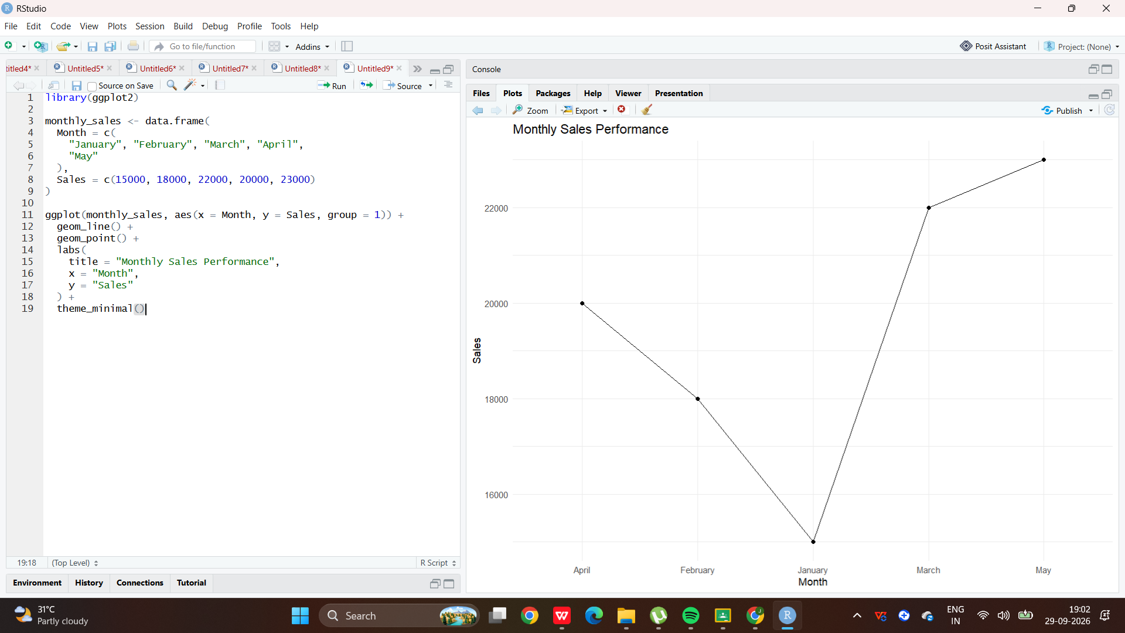

2.Bar Chart – Employees by Department
Code:
library(ggplot2)

employees <- data.frame(
Employee_ID = c(1, 2, 3, 4, 5),
Department = c(
"Sales", "HR", "Marketing", "Sales", "HR"
),
Years_of_Service = c(5, 3, 7, 4, 2),
Performance_Score = c(85, 92, 78, 90, 76)
)

ggplot(employees, aes(x = Department)) +
geom_bar() +
geom_text(
stat = "count",
aes(label = after_stat(count)),
vjust = -0.5
) +
labs(
title = "Employee Distribution by Department",
x = "Department",
y = "Number of Employees"
) +
theme_minimal()

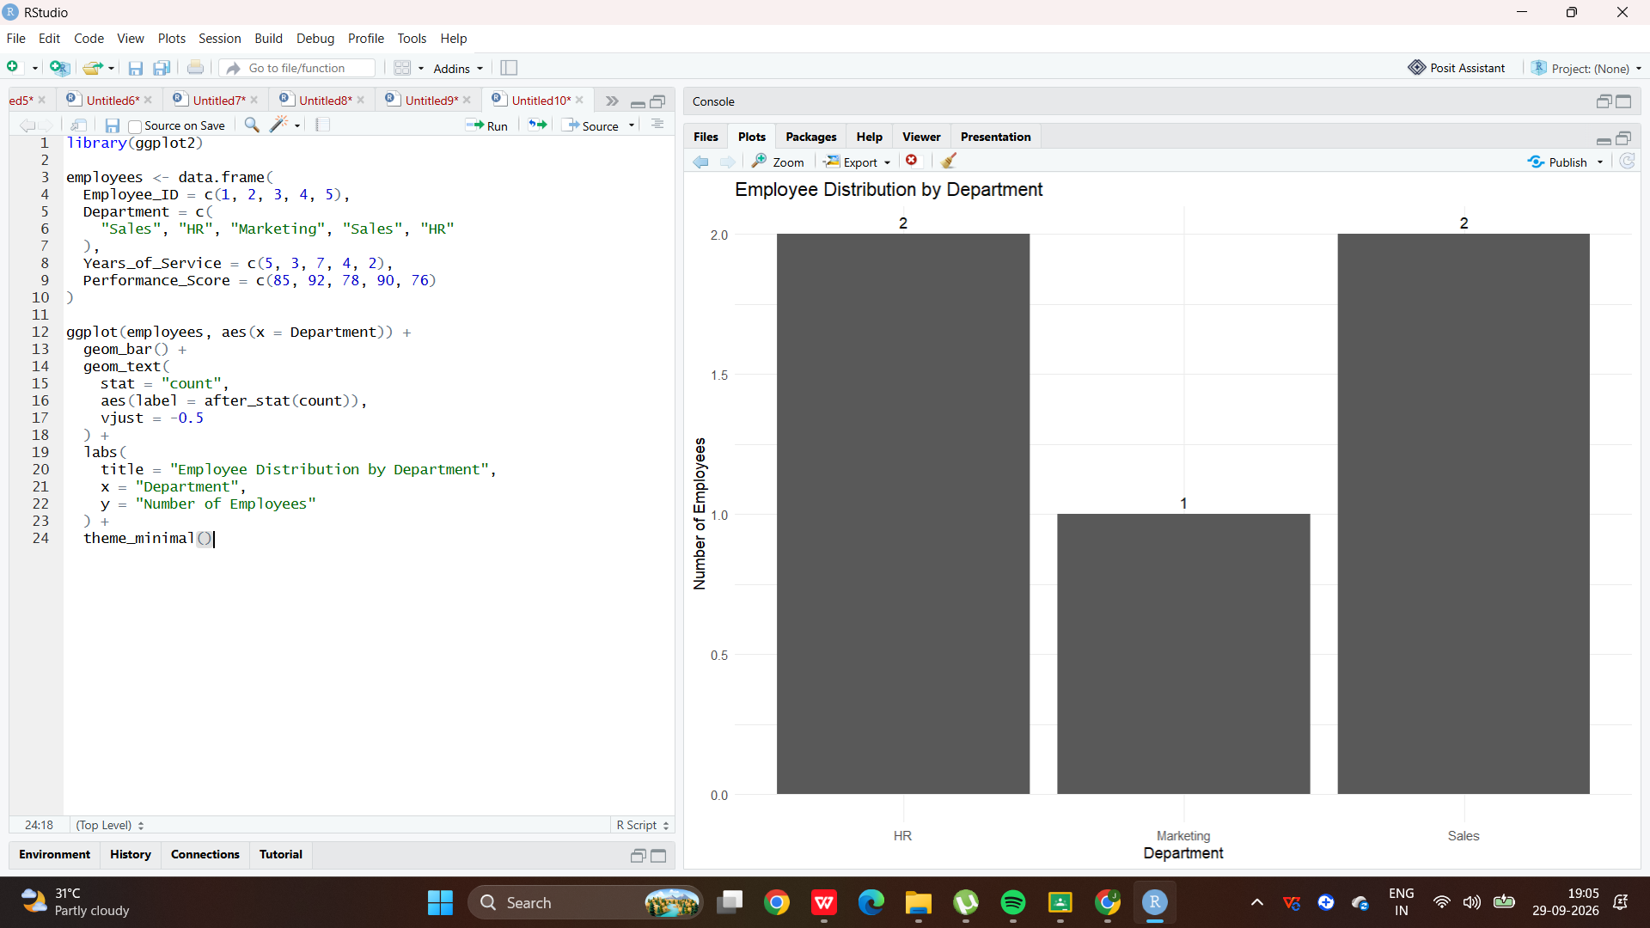

3.Scatter Plot – Years of Service vs Performance Score
Code:
library(ggplot2)

ggplot(
employees,
aes(x = Years_of_Service, y = Performance_Score)
) +
geom_point(size = 3) +
geom_smooth(method = "lm", se = FALSE) +
labs(
title = "Years of Service vs Performance Score",
x = "Years of Service",
y = "Performance Score"
) +
theme_minimal()

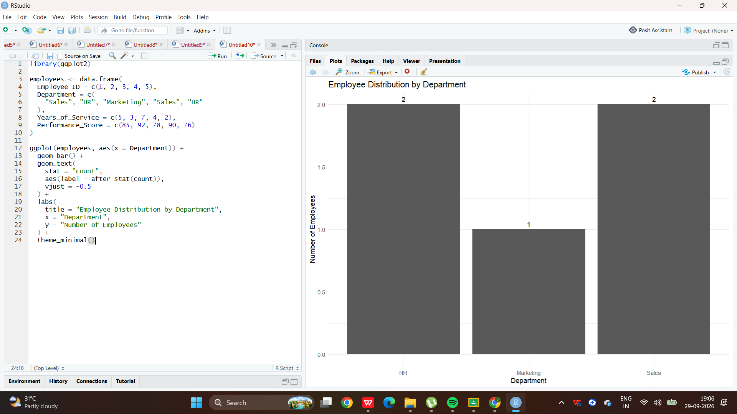

4.Interactive Dashboard
Code:
library(plotly)

# Line chart
line_chart <- ggplotly(
ggplot(monthly_sales, aes(x = Month, y = Sales, group = 1)) +
geom_line() +
geom_point() +
labs(
title = "Monthly Sales Performance",
x = "Month",
y = "Sales"
) +
theme_minimal()
)

line_chart

